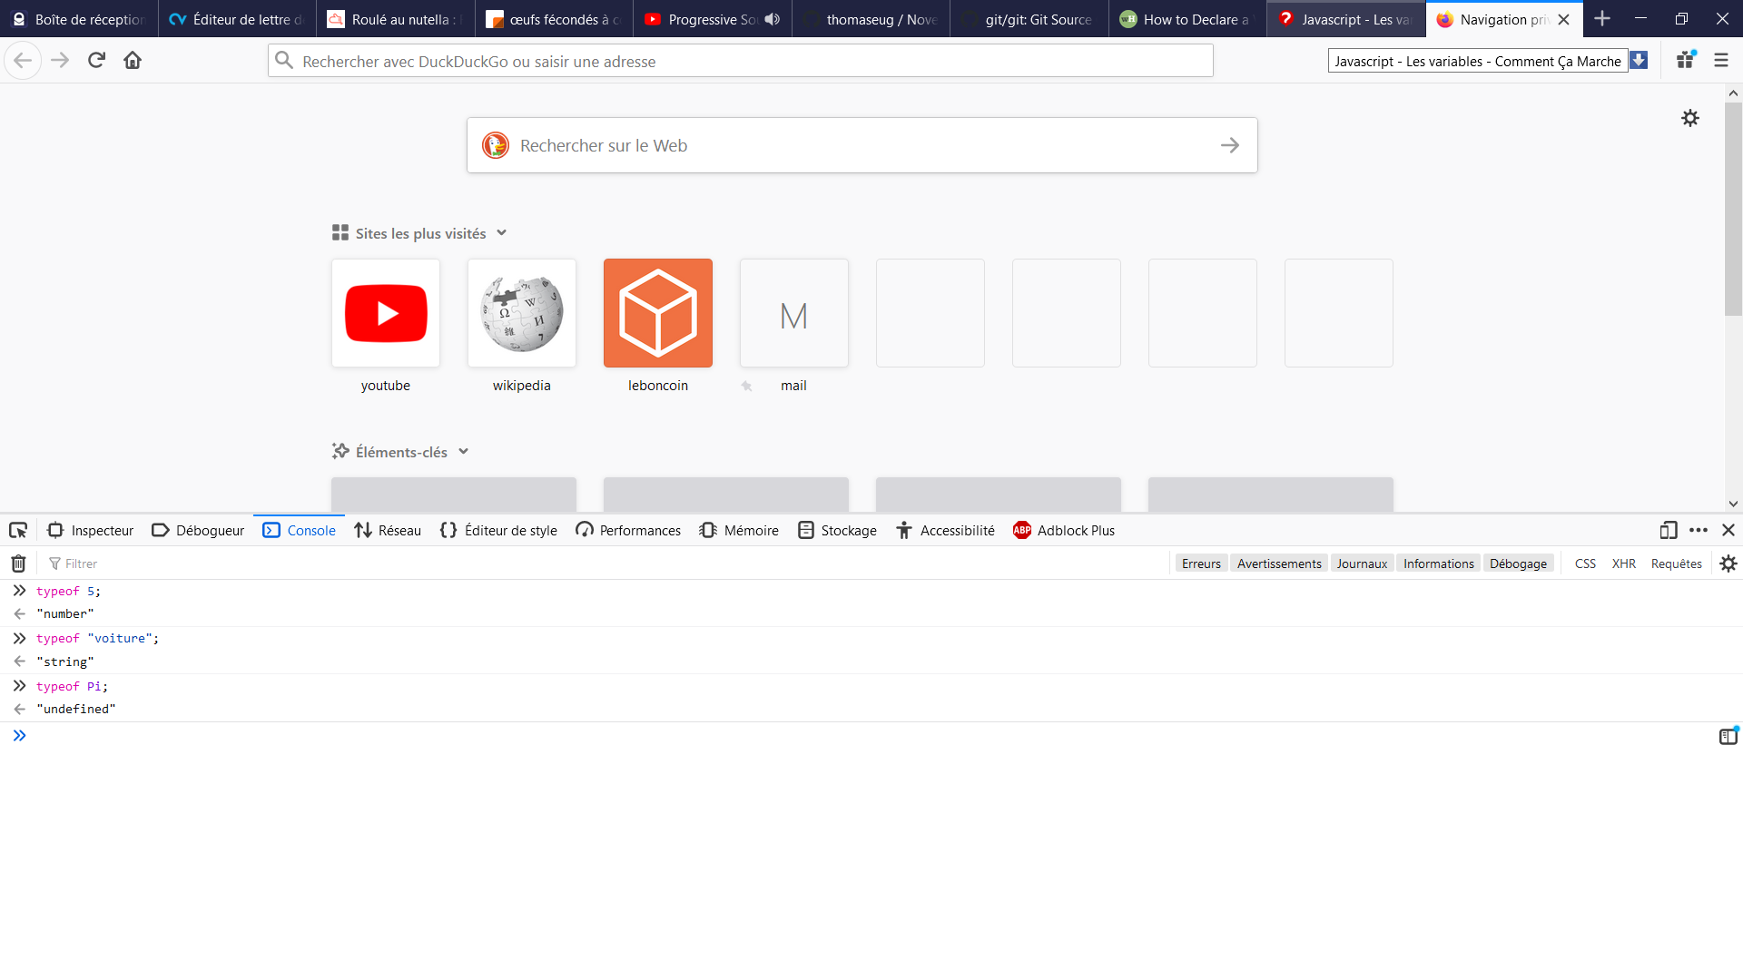
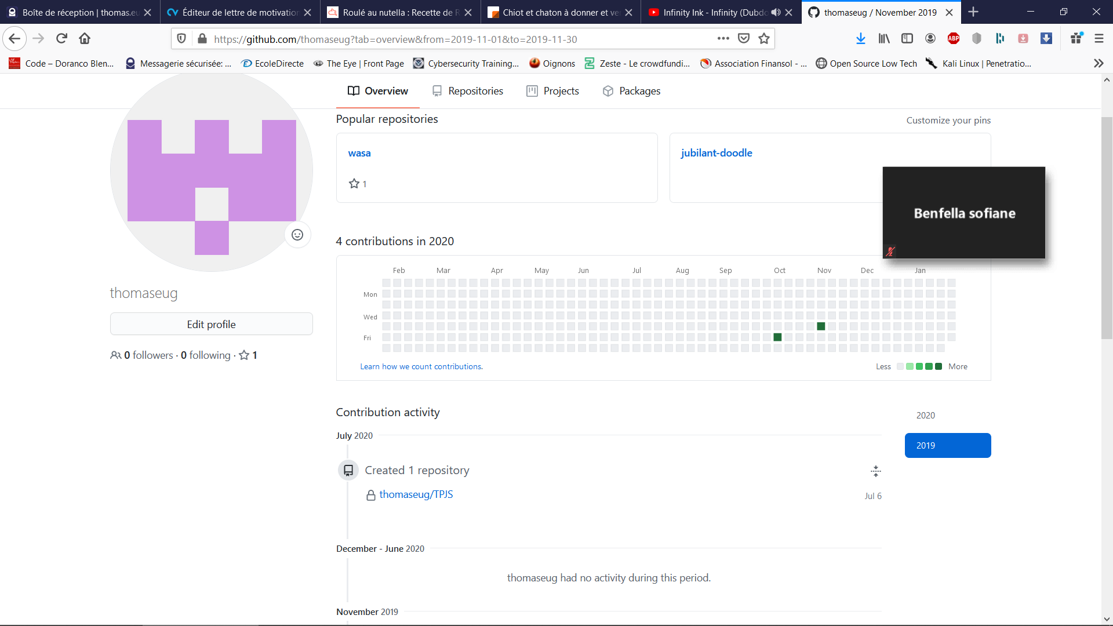

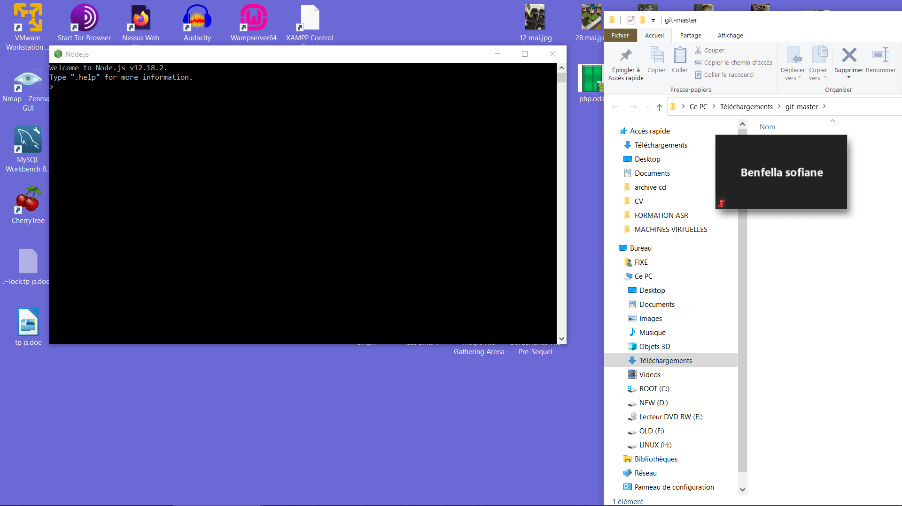

TP 2

1/ https://js.do/code/464513

2/ https://js.do/code/464520 (pour N = 66)

3/ https://js.do/code/464522

4/ https://js.do/code/464522

